050524/STBOSE

Basic Training SConf Workshop

Training exercise 1 – Available / Unavailable 2
Training exercise 2 – Available / Unavailable cont’d 3
Training exercise 3 – Attach / Detach 4
Training exercise 4 – Variables Intervals 6
Training exercise 5 - Screens 9
Training exercise 6 – Building Reports 16
Training exercise 7 – Forced user input 25
Training exercise 8 – Guided Questions 29
Training exercise 9 – Characteristics Dependencies 32

Training exercise 1 – Available / Unavailable
When inserting the characteristic surface Finish no 2 "Steel", it will in the same time make the option characteristic Handle "Elegant" not available for choosing in one of the next steps of defining the characteristics for the main item 10 – Easyflex Garage Door.
Task: Create these two rules in the right place, create a Version, go back to CTO – Interim Order and check out how it works.

Product : EASYFLEX_GDFINISH_2
Steel finish

Insert Tab Rule

Putting it on the Insert tab will fire the rule when the characteristic is chosen (inserted) into the configuration.

Operate | Always
 | Unavailable | "EASYFLEX_GDHANDLE_ELEGANT"
 | Message | "This selection makes the handle Elegant unavailable"

Delete Tab Rule

In the same time one have to make sure that the removal of the "Steel" finish as a chosen characteristic will make the "Elegant" handle again available. Therefore a
contradictory Delete tab rule have to be created.

Operate | Always
 | Available | "EASYFLEX_GDHANDLE_ELEGANT"

-----------

Now, what happens if the user chooses to set the Handle characteristic previous to choosing the Finish?

Continue with exercise 2 to answer that question.

Training exercise 2 – Available / Unavailable cont’d
Since there is no particular order that one have to add characteristics to a configurable item one also have to control what should happen if the user chooses to select the characteristic option Handle "Elegant" previous to the Finish "Steel".
So the other way around also have to be secured by making the same rules for the characteristic option Handle "Elegant".

Task: Create these two rules in the right place, create a Version, go back to CTO – Interim Order and check out how it works.

Product: EASYFLEX_GDHANDLE_ELEGANT
Elegant w/hardware kit

Insert Rules

Putting it on the Insert tab will fire the rule when the characteristic is chosen (inserted) into the configuration.

Operate | Always
 | Unavailable | "EASYFLEX_GDFINISH_2"
 | Message | "This selection makes the finish STEEL unavailable"

Delete Rules

In the same time one have to make sure that the removal of the "Elegant" handle as a chosen characteristic will make the "Steel" finish again available. Therefore a contradictory Delete tab rule have to be created.

Operate | Always
 | Available | "EASYFLEX_GDFINISH_2"

Training exercise 3 – Attach / Detach
In this exercise we should make sure that when choosing North America as a Country characteristic option, also the 115 V Power system will be used as well as a mandatory Childproof Door stopper.

The difference from the previous 2 exercises is that this time we make the characteristic options directly included in the option list when choosing Country "NA". In addition will the "115 Voltage" be not mandatory, which in turn gives the user the possibility to choose another Power system afterwards.
On the contrary will the "Childproof Door stopper" be mandatory and not removable without firstly switch to another Country.
(Beware. This last comment is a bit tricky to handle correctly in CTO. If the user changes his mind and switches to another Country, the "Childproof" will get an "X" on the Line in CTO. This is not enough to remove the option. MAKE SURE YOU ACTUALLY MARK THE LINE AND REMOVE IT. Then press Apply to test if the removal worked.)

Task: Create these two rules in the right place, create a Version, go back to CTO – Interim Order and check out how it works.

Product : EASYFLEX_GDCOUNTRY_NA
North America (United States, Canada)

Insert Tab Rule

The "Detach" starting this Insert tab rule makes sure that if the user once again chooses the Country "NA" characteristic option, will not have another Power system included. The "$Char(13)" in the Message is the ASCII sign for a Line break. The "&" sign is concatenating strings.

Operate | Always
 | Detach | "EASYFLEX_GDPOWERSYS_115"
 | Detach | "EASYFLEX_GDPOWERSYS_240"
 | Detach | "EASYFLEX_GDPOWERSYS_400"
Operate | Always
 | Attach | "EASYFLEX_GDPOWERSYS_115" | As Quantity | Option
 | Attach | "EASYFLEX_GDESTOP_CHILDPROOF" | As Quantity | Required
 | Message | "The Childproof door emergency stop and " & $Char(13) & "Power supply = 115 V is automatically " & $Char(13) & "selected for the North American market."

Delete Tab Rule

In the same time one has to make sure that the removal of the "NA" Country as a chosen characteristic will remove the "Childproof Door stopper". Therefore a contradictory Delete tab rule have to be created. Note that this will set the "X" on the line in CTO but NOT remove it from there. This has to be done manually.

Operate | Always
 | Detach | "EASYFLEX_GDESTOP_CHILDPROOF"

Training exercise 4 – Variables Intervals
This is one of the most important exercises. It works well in the CTO environment but limitations in SConf to the Update tab makes it not work the same. The trick here is that we want to set limitations to values on characteristics that are Variables which contains no set of valid characteristics to choose from.

To do that we have to create new Variables in SConf WS from which the limited values should be checked. Those limits are NOT visible in CTO but the user will get a notice if he/she goes beyond and SConf will then set it to the one of the limits that are closest and then letting the user change it afterwards.
In addition there is an "Interval" variable added which via a Reminder will modify an "uneven" figure to the one set in the Interval. In this case all entered figures will be rounded to the closest 5 cm since it is rather impossible to build garages with a narrower scale.
The task will take both the Height and the Width of the 10 – Easyflex Garage Door into validation.

Task: Create these variables and rules in the right place, create a Version, go back to CTO – Interim Order and check out how it works.

Product : EASYFLEX_GDHEIGHT
Height of garage door (in mm)

Variables

Start with adding the new variables for the characteristic variable. Also add the upper and lower limitations and the minimum interval values directly into the column.

Name | Description | Type | Value
_VarValue | _VarValue | String
_VarType | _VarType | String | VARIABLEVALUE
_VarRevision | _VarRevision | String
_SalesUOM | _SalesUOM | String | mm
VarMax | VarMax | Number | 4800
VarMin | VarMin | Number | 1800
VarInterval | VarInterval | Number | 50

So this will make it impossible to build a Garage Door higher then 4,8 meters or lower then 1,8 meters.

Now do the same for the Width.

Product : EASYFLEX_GDWIDTH
Width of garage door (in mm)

VarMax | VarMax | Number | 10000
VarMin | VarMin | Number | 2200
VarInterval | VarInterval | Number | 50

Task : ValidateNumericVariable

Rules

To take use of these values created on each characteristic one need to define a Task which should be fired when values are entered in the value field in CTO.

Since _VarValue and VarMin are of a different kind there has to be a conversion function in between ($Cint / $CStr).
To round a value to the VarInterval value a $Mod is needed to find out how large the reminder is in a division. It is then subtracted from that value which makes it even compared to the stated VarInterval. But this value may anyway be outside the valid range having to be corrected to fit inside the range.

Operate | Always | VarMin > $CInt(_VarValue) OR VarMax < $CInt(_VarValue)
 | Message | "The valid range is between " & $CStr(VarMin) & " and " & $CStr(VarMax) & "." & $Char(13) & "The valid interval is " & $CStr(VarInterval) & "."
 | Set | _VarValue | $CStr(VarMin) | VarMin > $CInt(_VarValue)
 | Set | _VarValue | $CStr(VarMax) | VarMax < $CInt(_VarValue)
 | Message | "Your value has been rounded to closest maximum or minimum limit."
Operate | Always
 | Define Local Var | Reminder | Number
 | Set | $local.Reminder | $Mod($CInt(_VarValue), VarInterval)
Operate | Always | $local.Reminder > 0
 | Set | _VarValue | $CStr(($CInt(_VarValue) - $local.Reminder))
 | Message | "Your entered value is not valid and has been rounded down to " & _VarValue & " mm." & $Char(13) & "The valid interval is " & $CStr(VarInterval) & " mm."

Group : EASYFLEX_GDHEIGHT
Height of garage door (in mm)

Update Tab Rule

The Task is then fired by a Call for every characteristic belonging to a Group. The Update tab is used to make it fire off each time a change is made to the Variable value.

Operate | Always
 | Call Task | ValidateNumericVariable

Now do the same for the Width Group.

Group : EASYFLEX_GDWIDTH
Width of garage door (in mm)

Update Tab Rule

Operate | Always
 | Call Task | ValidateNumericVariable

Training exercise 5 - Screens
This exercise is compiled to give a hint of what can be done using User input pop-up screens. It will create a pop-up screen triggered from a chosen characteristic which gives the user a possibility to choose characteristics from the screen instead of the left pane in the offline SConf or in the online Create Config dialogue.
To create screens one needs to have a HTML editor such as MS Front Page or similar. It is not necessary do know any HTML coding since those facilities are not used.

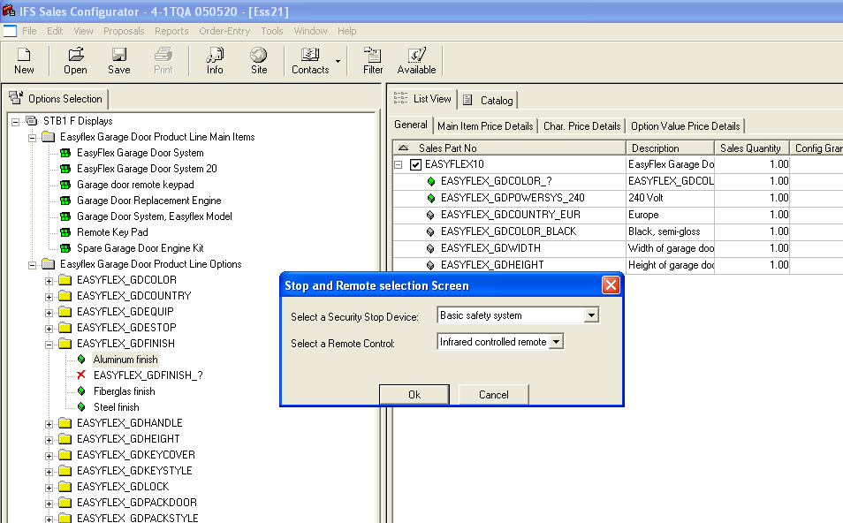

Task: Create the screen and the rule in the right place, create a Version and check it out in CTO and in the offline SConf.

Screen Generator

This exercise is performed basically under the Design subsystem of SConf Workshop.
Start by creating a new Screen and then click on the Browse-button (This imply that one also have an HTML editor associated – if not, associate it to the file type html in the File Explorer).

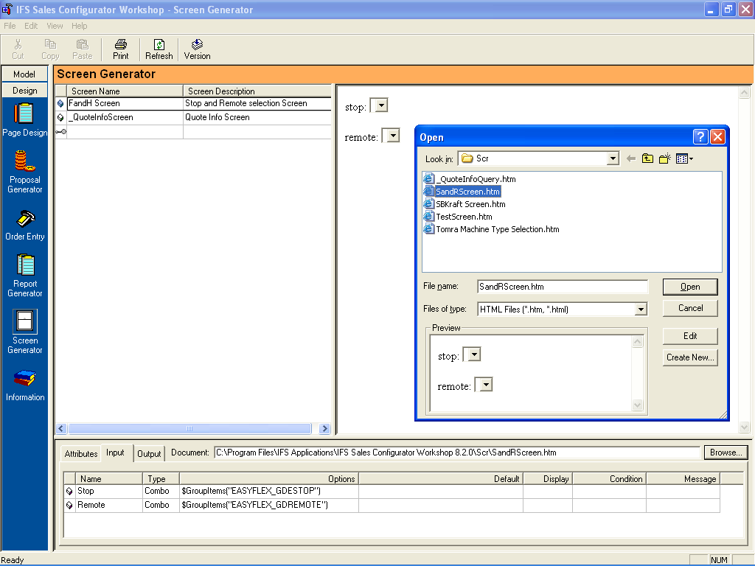
To create a new html file start with pressing the Create New… button and name the file.
Then mark it and click on Edit. It will get you into FrontPage.
Note. After you are done with changes in FrontPage you will have to click on Open to fetch the file changes you have done into the Screen Generator.

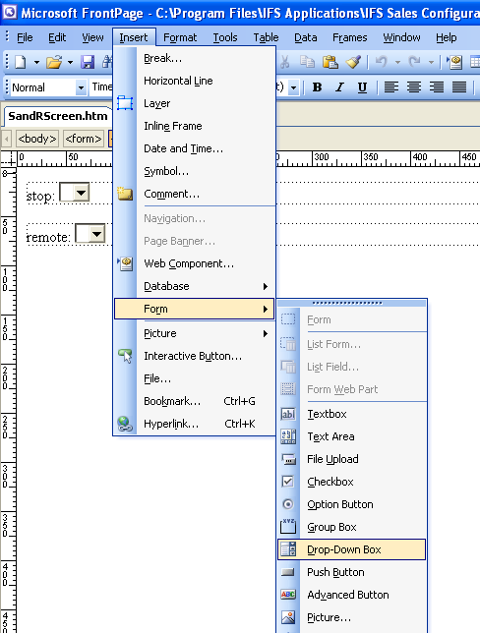

Field creation in MS FrontPage

Field types possible to use:

Text fields, Combo boxes, Scrolling textboxes, Checkboxes and Radio buttons.
-----------

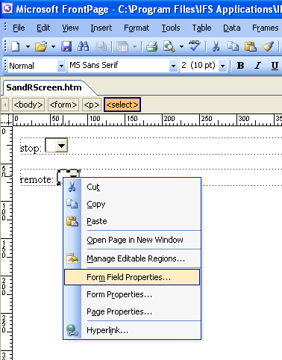
For this purpose we will use two Drop-down box fields and when inserted to the screen, use RMB and rename them via Form Field Properties to something leading of your own choice (here named to stop and remote). The name to the left of the field doesn’t affect anything, it is just for guiding purposes and need not to be there.
It is the Properties naming that is important.

Close it and save it to a name of your choice. This htm file is then located via the path in the Screen Generator window.

Product Types - Global Variables

The Screen Generator is communicating via Global variables. A Global variable is created under the subsystem Product Types – Global variables. A Global variable is also a way to store values transferred from IFS why this can be very useful.
Create the following Globals in the right place. They will be used for moving the user selected choices from the Screen to the configuration later.
Name | Description | Type | Array
ScreenStop_Out | ScreenStop_Out | String | No
ScreenRemote_Out | ScreenRemote_Out | String | No

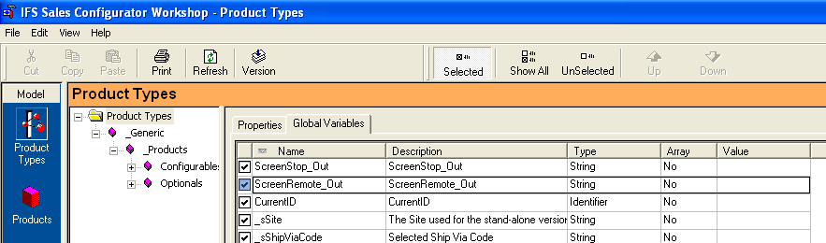

Screen Generator

The Screen Generator now contains three tabs – Attributes, Input and Output.

Attributes

Name and Type is given automatically from FrontPage settings while you type leading text for the user in the Description column field.

Input

The Input tab populates the (combo box) fields with contents from SConf.

Output

The Output tab gives the choices the user has made.
Attributes

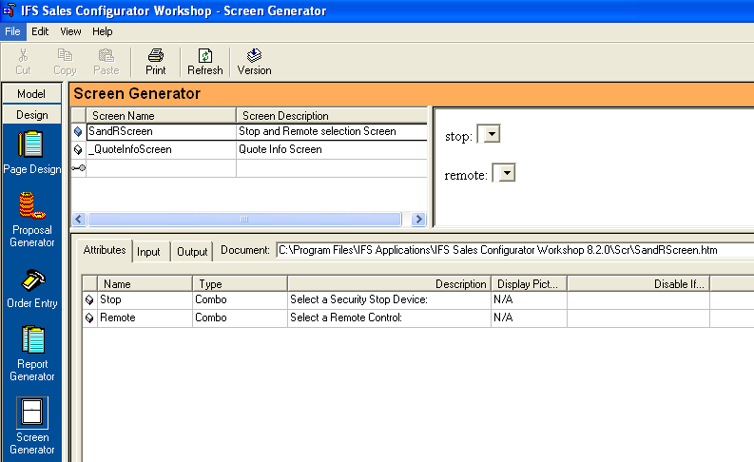

Type in a Description to each field you wants the user to perform an action on.

Input

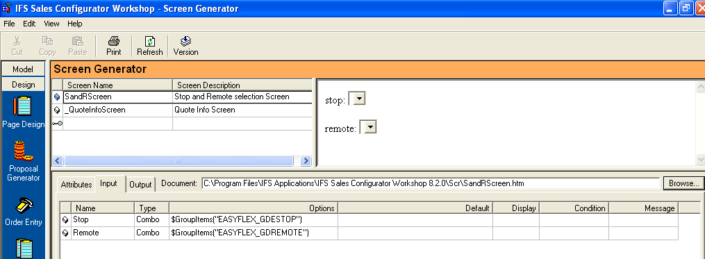

The Input contains what is populated in the fields and what is shown as default when the screen pops up. Add the below missing data. The following example will populate the dropdown boxes with the contents of the groups stated. If you want a default value show as a first value in the combo box you may enter it in the Default field.

Name | Type | Options | Default | Display | Condition | Message
Stop | Combo | $GroupItems("EASYFLEX_GDESTOP")
Remote | Combo | $GroupItems("EASYFLEX_GDREMOTE")

Output

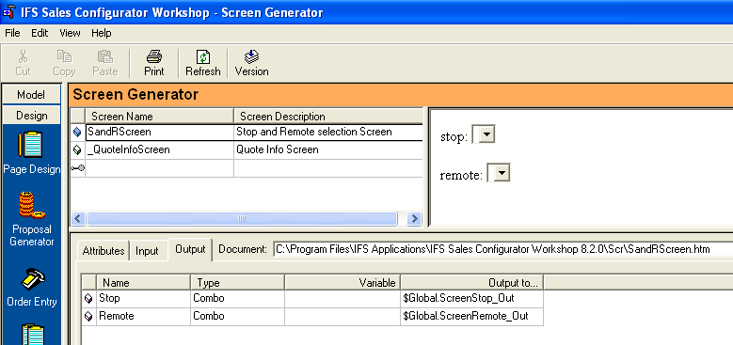

The Output tab contains the choices and inputs the user have done and stores those values in a global variable to be used to control what's going to be done in the Task following.

Name | Type | Variable | Output to…
Stop | Combo |  | $Global.ScreenStop_Out
Remote | Combo |  | $Global.ScreenRemote_Out

Product : EASYFLEX_GDFINISH_1 Aluminium finish

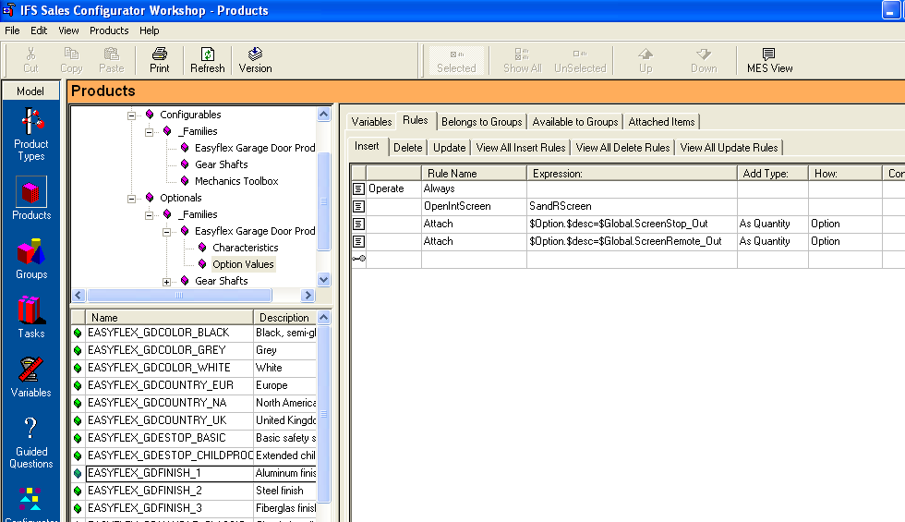

Insert Rules

Whenever the user adds the characteristic Finish 1 Aluminium, this will fire the Pop-up screen through the OpenIntScreen facility.
The Attach will take the user chosen characteristic stored in the global variable ScreenStop_Out and compare its description through the $desc variable to what’s in all Groups and attach it to the configuration when found. The same goes for the remote.

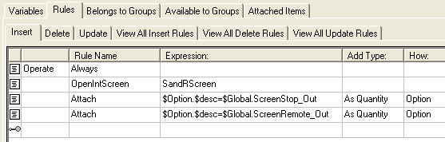

Delete Rules

Since a contradiction rule has to apply if the user changes his mind, the Delete tab must have a similar rule contradicting the insert rule.

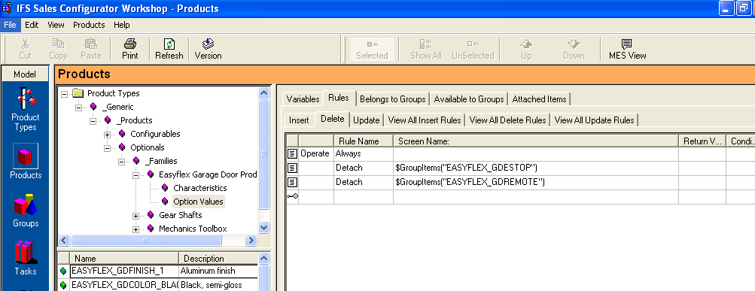

This will detach the previously attached characteristics (in fact the whole content of the group).

Generate a Version and test this new functionality by adding an Aluminium Finish to your configuration.

Training exercise 6 – Building Reports
Page Design

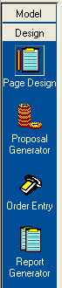
This exercise will guide you through the process of defining a simple report. Reports are built by components made in the Page Design subsystem and combined to a report in the Report Generator subsystem. This is equally working the same way for the subsystems Order Entry and Proposal Generator. The only difference is where your report turns up in the SConf client. This means that we will only go through this once for one of these subsystems; the Report Generator subsystems.

Task: Create a report consisting of several parts from the Page Design subsystem and place it under the Reports menu in the SConf client. Make a configuration and test the output report on that configuration. Print it as a Preview on the screen and then print it on a printer.

In the same way as when using Screens it necessary to have an HTML editor invoked and the creation and allocation of files is done in the same way too.

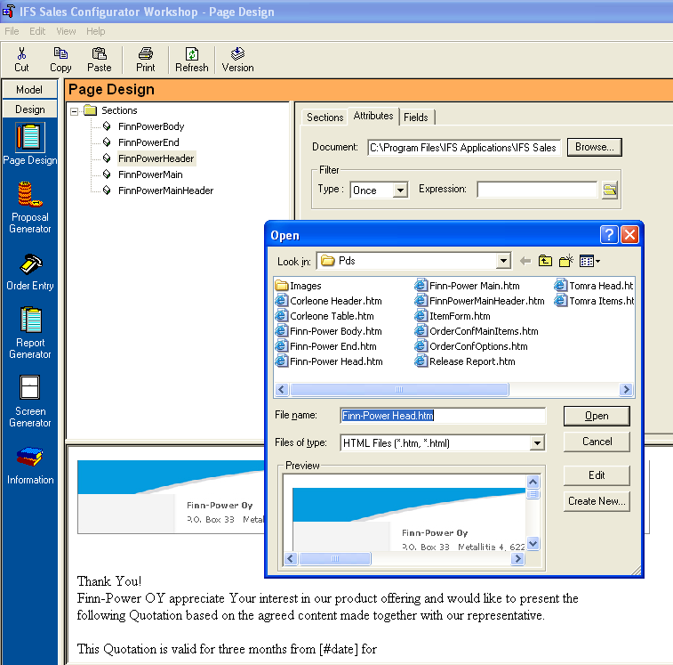
Under the Section part one define each section of the report that should be combined into the finished report.
When clicking on the Browse button you will open the connected HTML editor (pref. MS FrontPage) and the associated file.
If about to create a new section click on Create New…, give a name, mark it and click on Open to start editing the file.

Each section is an HTML file stored under the PDS directory of the IFS Sales Configurator Workshop directory. If pictures should be used they should be stored in the Images subdirectory of the PDS directory.

In our exercise we will make 5 sections:
- Header
- Main
- MainHeader
- Body
- End

Start this exercise by creating each section in the PDS subsystem, just by adding these 5 sections with a pre-extension in front i.e. XXHeader, XXMain … It is done under the Sections tab. In the Attributes you’ll find the connection to the HTML page as well as sorting and filter facilities (not covered here).
The Field tab will contain the fields that will be used in the report and will turn up automatically from the HTML file.

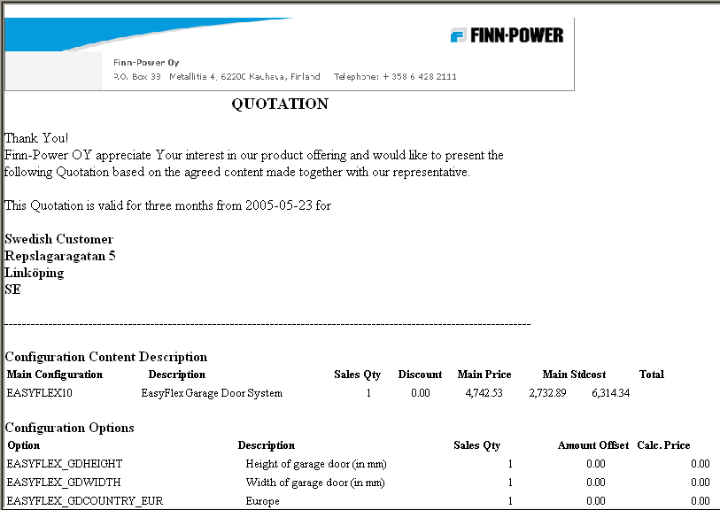
Header
Main
Main
Header
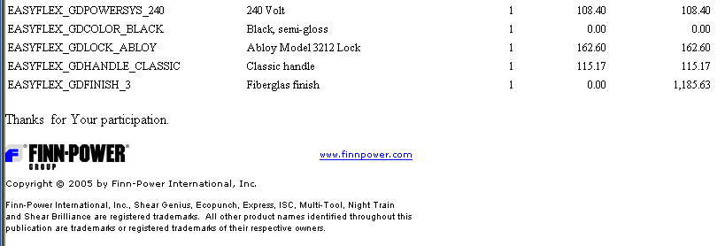
Body
End

To get data into the fields defined for each section Tasks are needed and will be called for just before the report is created.

Header

The Header section calls for a one time use of customer data and need not to loop through a set of data. We want to add an image, fetch some standard text, to fetch today’s date and finally get the customer information.

- The Image. To get an image like this into the report just store an image under the Image subdirectory. Go into FrontPage and do an Insert – Picture action.

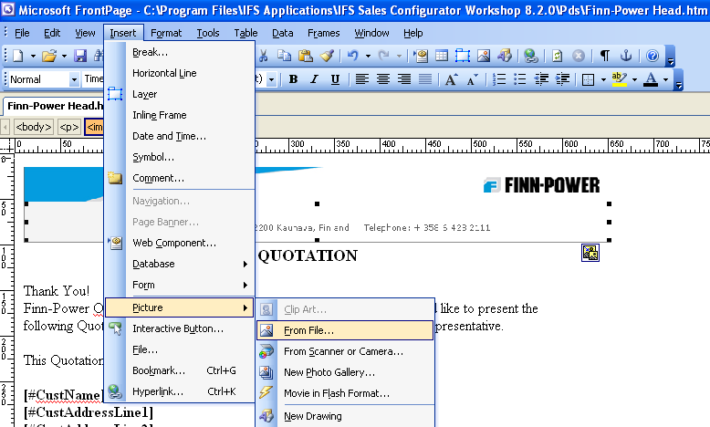

- Text. The following text mass from the QUOTATION header down to and in front of the Date field, can be entered directly into the HTML page and will be shown in the report as is (on the contrary to Screens where texts are not shown).

- The Date. The date field is using the standard global function of $Today ( ) to call for the computer’s calendar functionality.

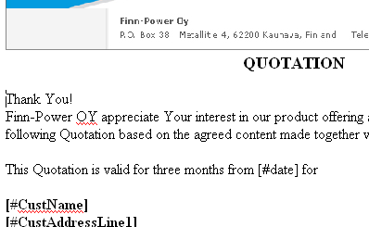

To create a field that should be populated in some way in the report one should use the [#fieldname] nomenclature. This will automatically create the filename in SConf WS Page Design Fields tab as shown below.

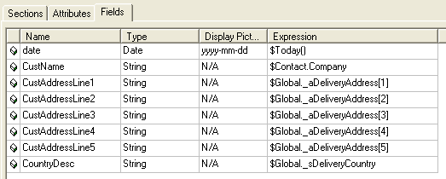

These fields behavior can then be altered in the Fields tab. Set the appropriate Type, eventually a mask in the Display field and finally from where the content of the field should be fetched from. In our case it is the standard function of $Today () that will fetch today’s date to the #date field.

- Next thing to fetch is the customer specific information. To get that data we will use some Global variables which contain information around the customer WHEN and IF we have chosen a customer from the Contacts button in the SConf client.
Add the fields above or find others in the Product Types Global variables area.

- Finally add the header for the main item that should be configured. In our case we will assume that the customer only configure one main item and then consecutively add chosen characteristics.
In FrontPage it will now look something like this:
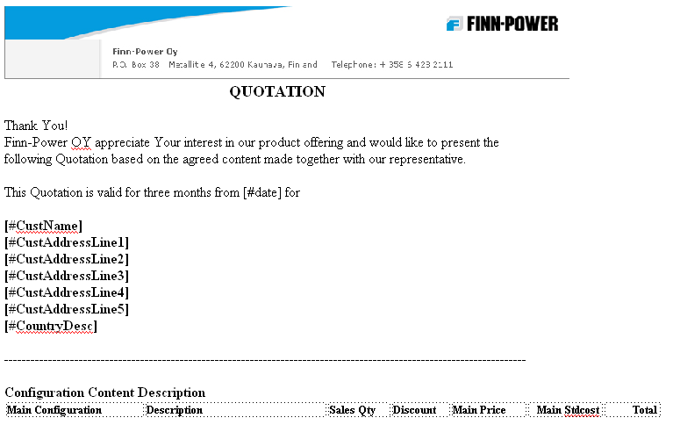

Main

The next section should present the information of the Main item configured by the user. The info should correspond to the header in end of the previous section.

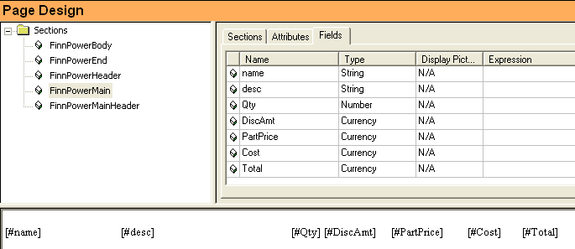

- Create a new HTML section and call it preferably XXMain. Go into the HTML file and add the above shown fields. Make sure they have the correct Data Type.
Important is that these fields will be populated from a Task and will therefore not need a fetch via the Expression column as in the Header above. The Task is described later.

MainHeader

Again there is a call for a header, this time for the loop around chosen characteristics.
No fields are needed. Just create an HTML file and type in text as shown below.

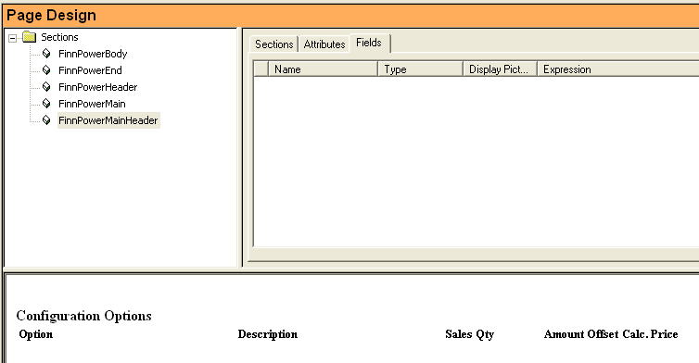

Body

The next section should present the information of the characteristics configured by the user. The info should correspond to the header in end of the previous section.

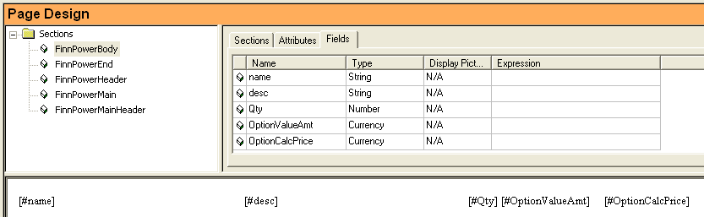

1. Create a new HTML section and call it preferably XXBody. Go into the HTML file and add the above shown fields. Make sure they have the correct Data Type.
Important is that these fields will be populated from a Task and will therefore not need a fetch via the Expression column as in the Header above. The Task is described later, but shortly this task needs a loop.

End

The final section will not contain any fetched data but will work as above described header sections. Create a new section and add text and an image.

Proposal Generator

No matter if you use Proposal Generator, Order Entry or Report Generator they work the same way. Your creation just turns up in different places in the SConf client.
The Descriptive name you give your Template Type (see below) will turn up as an output report in the SConf client.
If you set the Type to be a Title it will be shown as a subdirectory under Proposals, Order Entry or Reports. So if you want to call for a report, use Type Template.
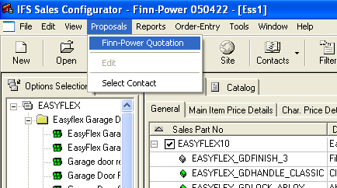

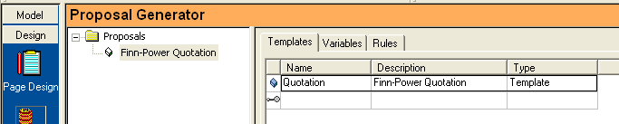
Since we have created 3 sections that calls for data we need to populate these forms with data and in our case we decide to use some predefined Tasks and some specifically designed for our purpose. For those not needing to call for any data, like headers, we just make calls for these forms. A form to be populated just once it is possible to use Form as well but it must be preceded by a Task fetching this data like our XXHeader. These calls for Tasks are made under the Rules tab in each subdirectory.

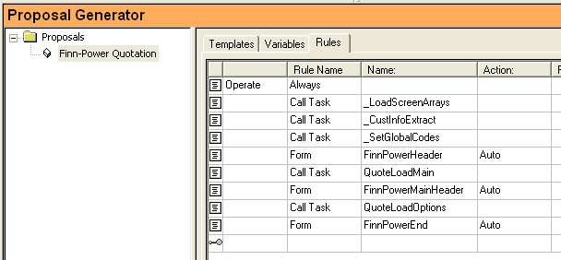

The following steps will create the report:

- To allocate values for the Customer information you can use the three consecutive standard Tasks. Then make a call for the Form XXHeader. Action is Auto since we use Tasks to fetch the data. This will populate the XXHeader part of the report.

- The second issue is to populate the main item form via the call for another Task.
Call this task QuoteLoadMain for instance.
This task must firstly be created under the Task subsystem under the Model pane as a Type Routine.

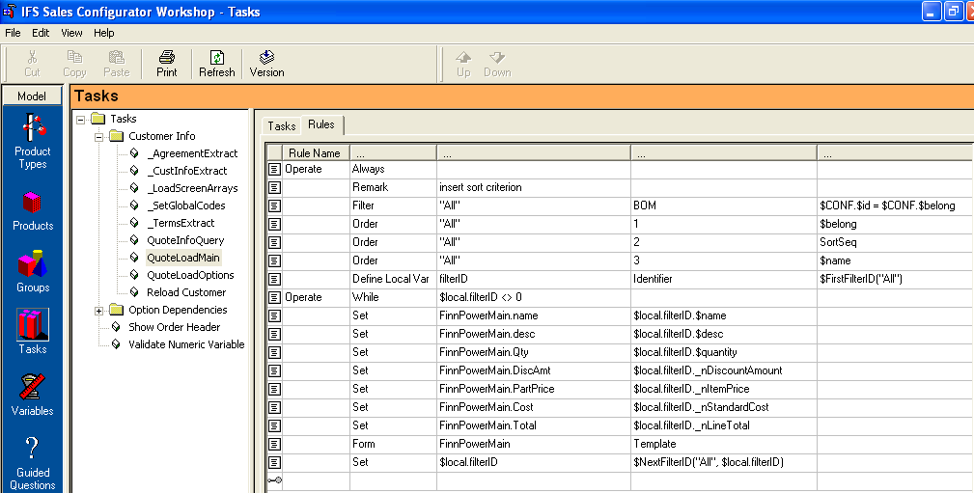

Task – QuoteLoadMain

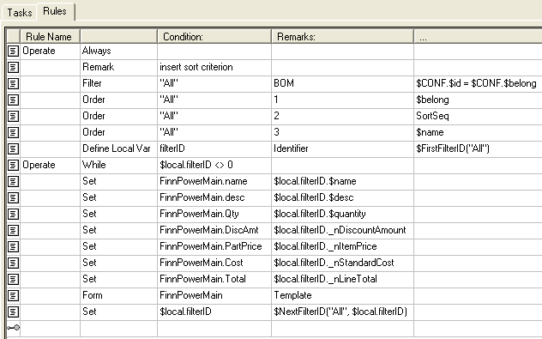
1.
2.
3.
4.
5.
6.

- Filter out all Main Items from what has been chosen. (=)
BOM means those on the right side (chosen ones). $CONF refers to chosen items on the right side (main items or characteristics). $belong identifies Main Items and $id identifies uniquely any characteristic or main item. See SConf WS Help for further info.
- Order these Main Items if several in this way.
- Create a local var id to contain the id of each Main item. When none, stop looping.
- Allocate fetched values to the Page Design section defined variables
- Populate the Page Design section
- Fetch the next Main Item

- Then we will call for the header XXMainHeader before going into
the next Task and fetch data to the characteristics loop.

- The fouth issue is to populate the characteristics form via the call for another Task.
Call this task QuoteLoadOptions for instance.
This task must firstly be created under the Task subsystem under the Model pane.
Task – QuoteLoadOptions

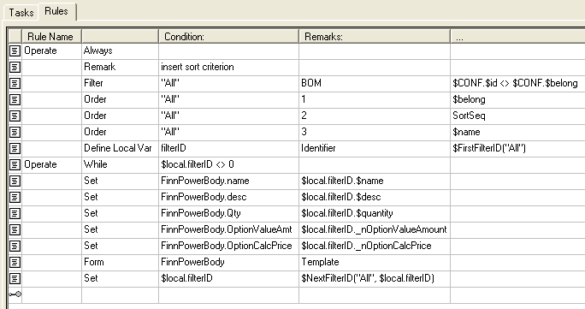

This task is in great extent equal to the previous task QuoteLoadMain except for that it looks for “non” Main items, i.e. Characteristics using the “separate from” sign “<>”.

Of course it calls for another form to be populated, here XXBody.

5. Final step is to load the Form footer of the report which needs for a call of the last
section called XXEnd.

Training exercise 7 – Forced user input
There are other examples in other places presenting this task in different ways but this way has been found work really well and is simple.
The task is to force the user to input selections that is necessary to have a working configuration. Using the Mandatory Characteristic setting in CTO is doing the same thing if not having a default value set. BUT if the users have hundreds of characteristics and don’t want them presented in one long row this facility can be very useful. It is possible to attach the below described XX_? characteristic “along the road” instead of all in the same time.
This works well in the SConf client but shows to the best in CTO since if a user tries to save a configuration without having made all necessary inputs it will not be possible to save the configuration. In the SConf client this can be controlled but in a more difficult way since there is no automatic check if the characteristics exists. If no explicit rule is made for checking the ORDERS message will stop anyhow in the Incoming CO inbox to CTO.

Note that this is usable for Discrete characteristics only.

Task: Create a mandatory input characteristic which is triggered by another characteristic and that have to be switched to a valid choice before being able to save.
Test it in both CTO and SConf.

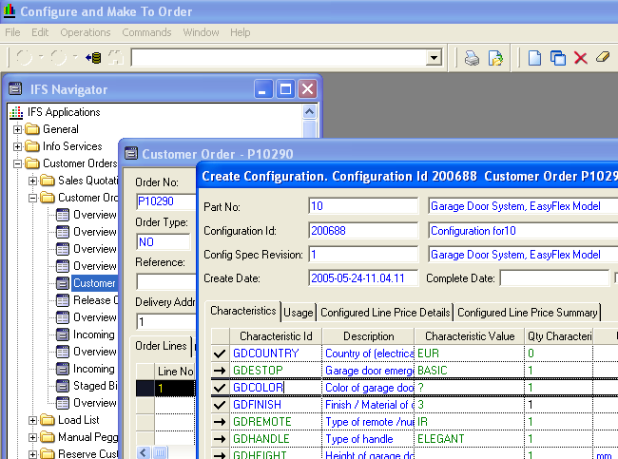

Product EASYFLEX_GDCOLOR_?

Start by deciding which characteristics that should be using this forced facility.
In this task we will set the characteristic Easyflex_GDCOLOR to need an input from the user.

To start with, add a new characteristic (that doesn’t exist in CTO) under the Product subsystem in SConf WS. In our case we call it Easyflex_GDCOLOR_?.

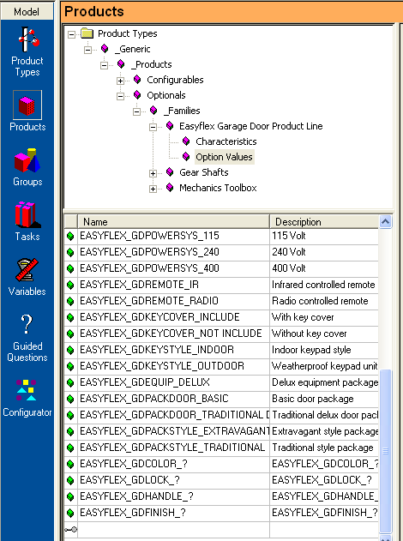

Then you can choose where to having it triggered.

IMPORTANT
- If you want it to trigger directly when the CTO Create Config screen opens, the checked characteristic must be put on the Base Part in the Products subsystem, here 10 instead of EASYFLEX10 (the Sales Part).
- On the other hand, if wanting it to trigger similarly in the SConf client it has to be put on the Sales Part and not on the Base Part, i.e. EASYFLEX10 and not 10.

The difference is important to know: in CTO we configure on the Production Base Part
but in SConf, the sales tool, we do it on the sales part.

Don’t forget to switch it to Option, else it will not be possible to remove easily.

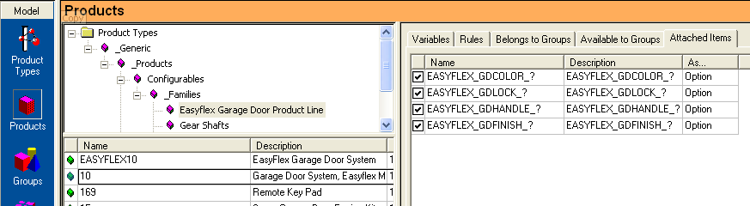

One must not forget to apply the removal of this characteristic when a choice is made. On each possible choice there has to be a Detach of this XX_? – characteristic. This is done on the Insert tab of each Characteristic.

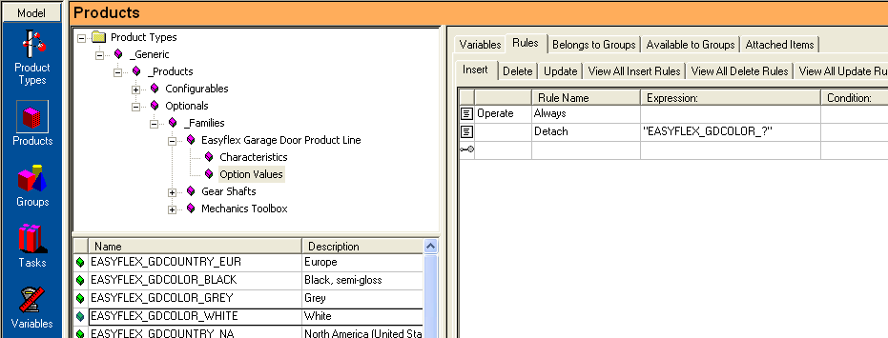

BUT, this would remove the XX_? for good and that is not what we want since it should still be necessary to add a color. Therefore we must add the XX_? characteristic on the Delete tab as well so that the removal of the real color used results in giving the XX_? back to the configuration telling the user that he/she still must add a color.
Attach it as Option.

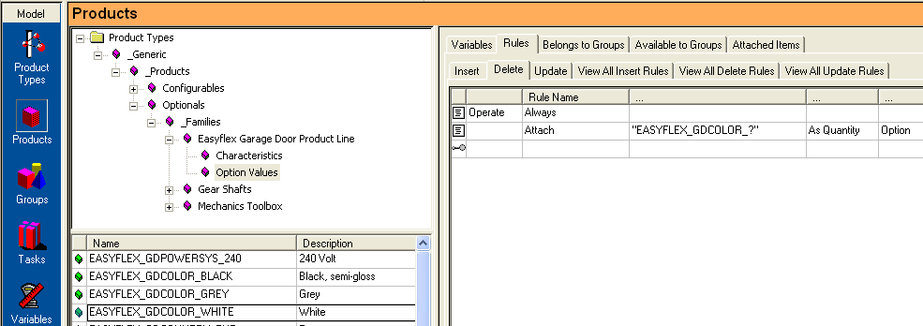

If you want this to work from the SConf point-of-view you have to maintain the CTO Base Part Char. accordingly. Particularly the Mandatory Characteristics need to be set properly since when running the CTO Create Config these affect the outcome of that screen as well.
In our case we set all characteristics to Not Mandatory in CTO Base Part char.

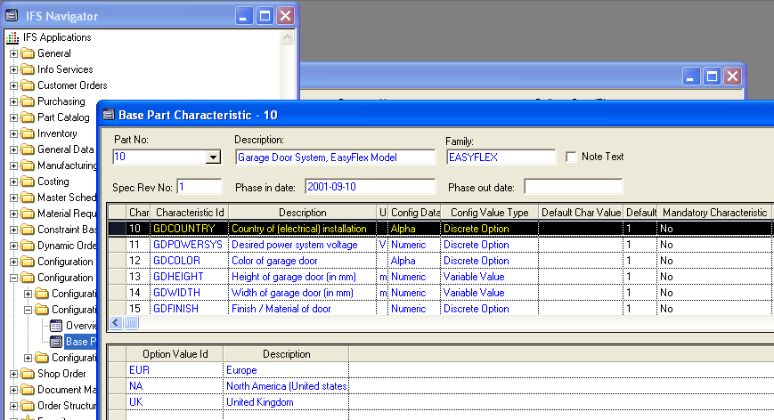
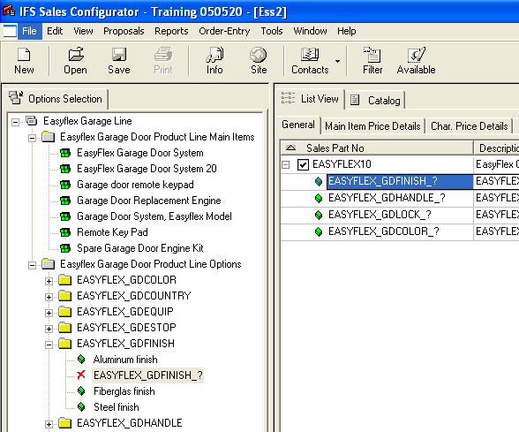
Note that the XX_? characteristic should NOT be made Available anywhere since it is not a valid choice.
In SConf this will be shown with the red X in the left pane.

Extra issue: Sometimes certain characteristics are not mandatory until another characteristic has been chosen. This can be done in a similar way but on the added characteristic.
You can now try that and add a XX_? characteristics that turn up when a specific characteristic is added. Don’t forget that it has to be removed and inserted under certain circumstances as described previously.

Training exercise 8 – Guided Questions
The larger the amount of possible Main items there exists for the user to choose from the better this functionality suites its purposes.

Preparation:
To be able to use Guided Questions you will have to turn on this facility for the user that you are using. For instance the “default” user.

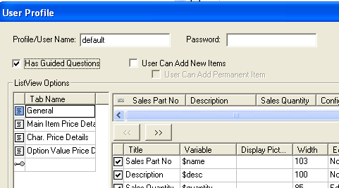
To do that you go to the SConf WS – menu File – User Profiles… Define.
Mark your user and click on Update… Check the Guided Questions checkbox and Save your profile (Save Users…).
You must create a new Version to get the new tab in the SConf client.

Next time you open the SConf client with this user you will have a new tab on the left pane for Guided Questions.
To start a series of Guided Questions one should click on the first level Question. The consecutive questions will follow automatically. It will eventually turn up with one (or several) main items which is the main purpose of Guided Questions. They will not directly guide in choosing Characteristics even if it is possible programmatically to save answers towards specific characteristics and positively store those values in Globals for later adding to the main item (not described here).

We will follow the “funnel”-structure as described below to create our GQ’s.
1 2 3 4
Color Price Quality
SC100 SC200
SC200 SC200
SC300 SC300 SC300 SC300
SC400 SC400 SC400
SC500 SC400
SC100 SC100 the funnel-principle
SC500
SC500

Described here is a way to look at the problem.

- We have a set of main items (h. SC100-SC500) that we want to guide the user through to find his/her best suited product. When this is done it is inserted in the right order pane in the SConf client and contiguous configuration can proceed.
- We add some GQ specific variables (h. Color, Price and Quality) that need to store values that the questions we put should answer to.
- We create a series of questions that we find ought to help the customer in deciding which main item suites him/her the best.
- When the customer replies on questions we will compare the answer (variable content) to the stored value of the Main item for that variable.

Follow a suggested workflow for creating your own Guided Questions:

- On a piece of paper sketch your structure like above.
- Go to the Product Types subsystem in SConf WS and on an appropriate level add your own GQ-variables. Call them GQ_XXX to separate them from the rest and add them under the Guided Questions category chosen on the right pane.
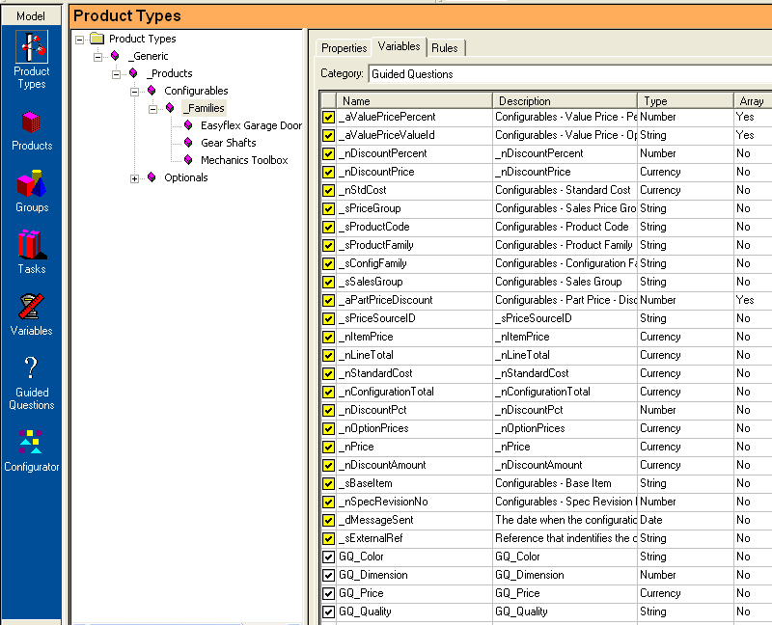
Choose appropriate level.

- Then go to the subsystem Products, to the Main item level and add values for each GQ-variable on each Main item product.

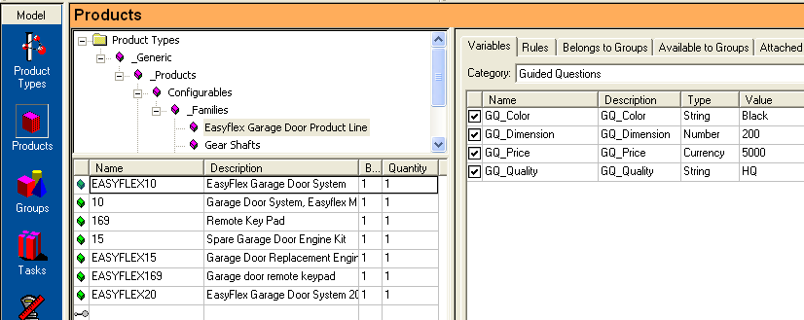
- Create a new GQ specific group to which you make all your main items belong.

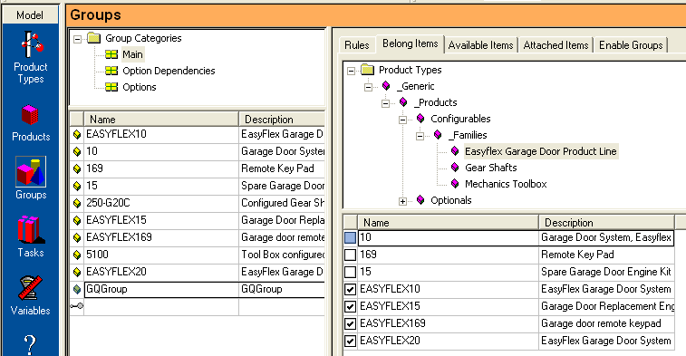

- Now you should create your specific questions you want the user to answer to.
This is done under the Guided Questions subsystem.

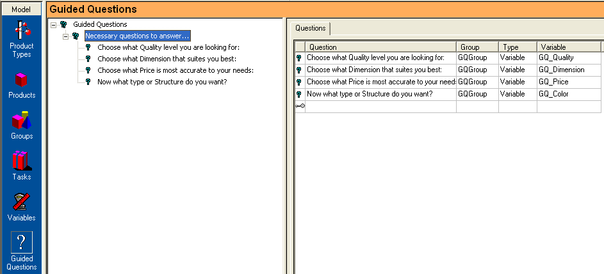

You must always start with an upper lever question that is of the type Title.
Subsequent to this Title question you then add your questions.
Add your questions, one for each variable you want to have an answer to and set the Type to Variable and the Group to the one you created above which contains your main items. Set the right connected variable as well.
The look of GQ in the SConf client will be similar to what is shown on the left pane.

6. Create a Version and try it out. Always start by clicking on the first upper question.

Training exercise 9 – Characteristics Dependencies

Option Dependencies

To some extent this exercise is doing the same thing as in exercises 1 and 2 but takes use of the predefined Task functionality of Option Dependencies. By using this functionality one get a better overview of the existing dependencies and to some extent a "cleaner" Workshop environment. At first glance this will look a bit more complicated.

In this exercise we should firstly add a few new characteristics to the 10 - Easyflex Garage Door item. This is done in the CTO environment and automatically triggered into the SConf WS tables.

The characteristics GDKEYSTYLE and GDKEYCOVER already exist in the CTO environment but are not connected to the 10 - Easyflex Garage Door item.
They are both Discrete Options with predefined values, which is a "must" and the only allowed type in this case.

New Characteristics on the configurable Part in IFS Applications.

Task 1: Add GDKEYSTYLE and GDKEYCOVER to 10 - Easyflex Garage Door item in Configuration Characteristics/Configuration Part Specification/Base Part Characteristics. All criteria are then fulfilled to trigger those Options into SConf.

Setting Option Dependencies on Discrete Options in SConf WS.

Switch to SConf WS and look up the new characteristics.

This time we will continue by letting the Discrete characteristic value of EASYFLEX_GDLOCK_ASSA if chosen, make GDKEYSTYLE value OUTDOOR
and GDKEYCOVER value INCLUDE not be accessible.
In this case also (as in most cases) a reverse rule have to be added to make sure those values will be accessible again if the lock ASSA is removed from the configuration.

Task 2: Take use of the predefined Option Dependency Groups and create tasks which are called on the Insert resp. Delete tab on the EASYFLEX_GDLOCK_ASSA. We shall make two options Unavailable when choosing the lock ASSA.

(Follow the instructions in the Option Dependency document.)

- In the Group sub system, create a new group under the Option Dependencies directory and call it UN_ EASYFLEX_GDLOCK_ASSA (there is a demand in the Task that the nomenclature has to be "UN_" + product id).
- In the Belong tab, select those two options that should be made unavailable when choosing the ASSA lock. Click in EASYFLEX _GDKEYCOVER_INCLUDE and EASYFLEX _ GDKEYSTYLE_OUTDOOR.
- In the Group "Unavailable Options" select the EASYFLEX_GDLOCK_ASSA for which there are options that should be made unavailable.
- Go to the Products sub directory and mark the characteristic EASYFLEX_GDLOCK_ASSA. Put a Call Task on the Update -tab. It should call the UN_Option_Insert –task and this one decides which characteristics that should be made unavailable when Inserting the ASSA lock.
- In the same way put the UN_Option_Delete -task in the Delete –tab.

In this way one can control several items also on higher levels by taking use of the same functionality but applying them on Product Types or Groups.

Task 3: Create a Version and test it all on the Configurable item in CTO. In the "List" only one valid possibility should be possible to choose for each of those two characteristics, if you select the ASSA GDLOCK. Deselect it and choose the ABLOY instead. Both alternatives should again be available for choosing.

